unioncloudhelp@lusu.co.uk

Clubs & Societies Fresher’s Fair Member signup
CLOUD WIKI

Union Cloud wiki
By lusu.co.uk

Intro
This guide is to explain how fresher’s will work this year, basically every society will have a QR code and link sheet on the desk as well as small slips that can be handed out. The fresher then scan this and or type in the link and then they can join your society on your website.
In the rest of this document is a how to step by step if you need to help them through this.

Step 1
Get them to download a QR scanner if they don’t already have one, a good to use that is available on both apple and android is i-nigma.

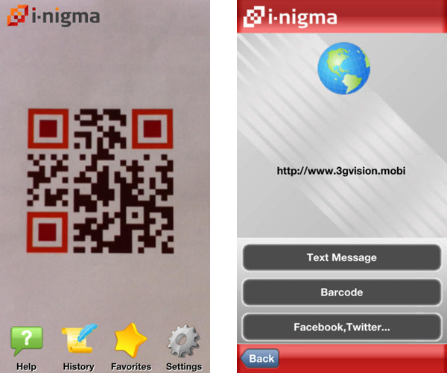

Step 2
Get them to open the app and scan your large QR code that is on your desk and this will take them to your website. They can also get here via typing in your societies link.

Step 3
Next they need to click join group and they’ll see your available memberships, if they are not already logged in they will be redirected to the login page.
Then they need to choose the membership type and click confirm.
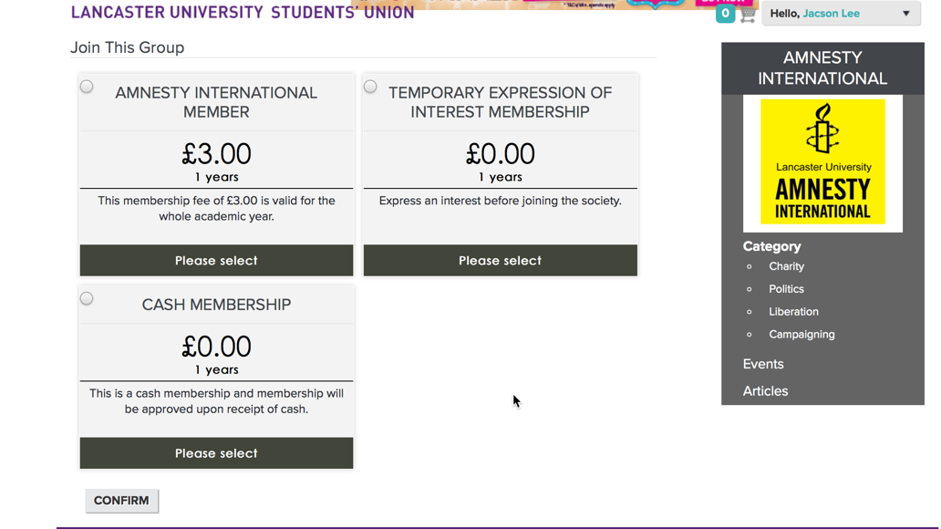

Step 4
Finally this will take them to the basket where they will be able to then checkout.
Or if they come off it and go back to the app and keep scanning and doing this process they will be able to add multiple memberships to their basket and check out at a later date.

Summary
So this is how it will work if they don’t want to do it there and then they can take a slip away with them, should you need any help with this the support team for the websites will be walking around.

